Report
on
Legal Awareness Programme
Organized by the Faculty of Law, University of Allahabad for the Year 2022-23

On 4th November 2023, the Faculty of Law at the University of Allahabad, under the leadership of Dr. Abhishek Kumar, Assistant Professor and Event Coordinator, conducted a Legal Aid Program at Central Jail, Naini, Prayagraj. This program was specifically designed to address the legal needs of the inmates, many of whom face significant challenges due to limited access to legal resources and a lack of understanding of their rights. The event began with an introduction by Senior Prof. Jai S. Singh, who emphasized the importance of legal literacy and the university’s dedication to social justice. The program was structured to provide comprehensive support through a combination of legal counseling and educational sessions. During the one-on-one counseling, inmates had the opportunity to discuss their cases in confidence with law students and faculty members, who offered personalized legal advice tailored to their specific situations. This allowed inmates to gain clarity on their legal standing and the options available to them, such as filing appeals or understanding the progress of their cases. Additionally, the program included educational sessions that focused on empowering the inmates with knowledge about their rights under Indian law, the legal process, and how to effectively navigate the judicial system. These sessions were designed to be interactive, encouraging inmates to ask questions and engage in discussions to deepen their understanding. By simplifying complex legal concepts, the program made the information accessible to all participants, ensuring that even those with little formal education could benefit. The impact of the program was significant, as many inmates expressed their appreciation for the legal guidance they received, noting that it provided them with hope and a clearer path forward. The jail authorities also lauded the initiative, recognizing it as a crucial support system for the prisoners. Overall, the Legal Aid Program not only addressed the immediate legal needs of the inmates but also equipped them with the knowledge necessary to advocate for themselves within the legal framework. This initiative reinforced the Faculty of Law’s commitment to extending its resources beyond the classroom to serve the broader community, particularly those who are most vulnerable.

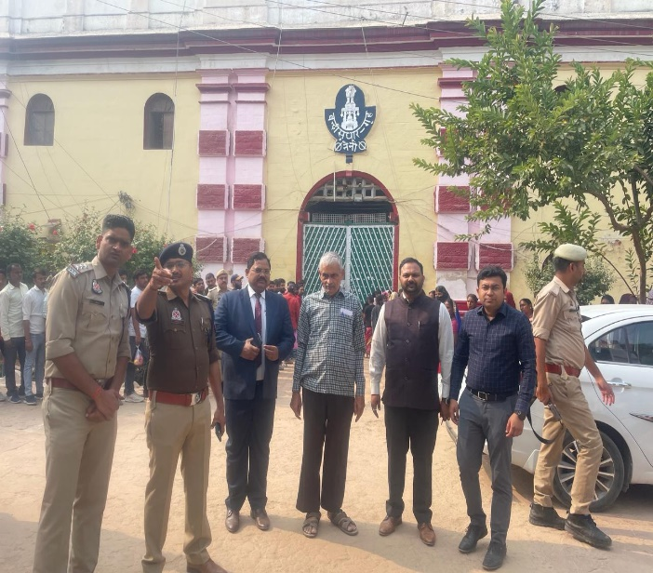
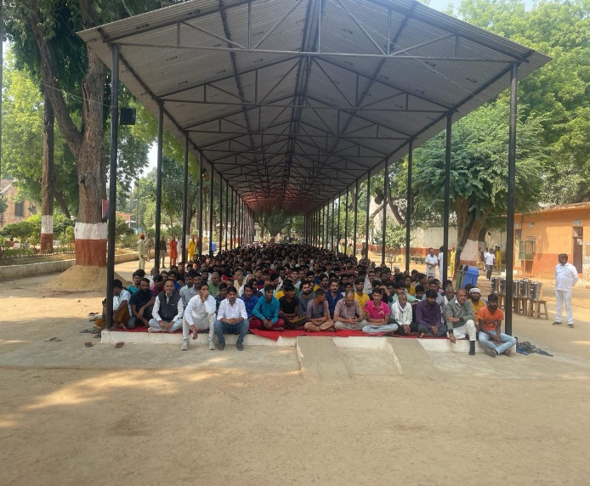
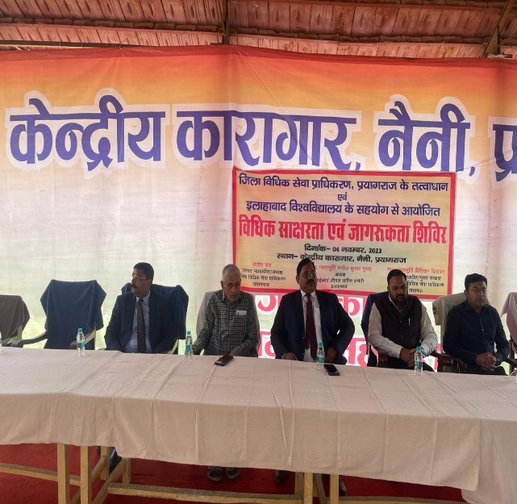
PROOF OF THE EVENT
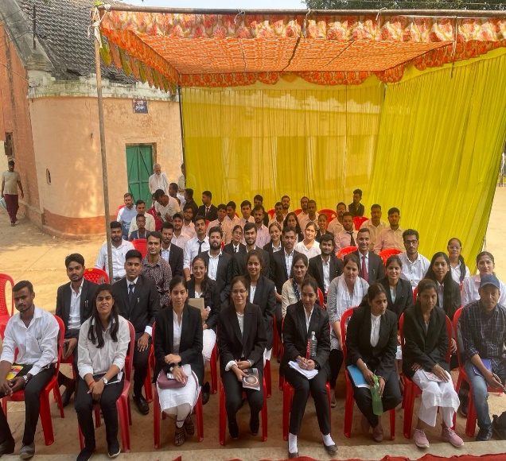

Dr. Abhishek Kumar (Event Coordinator)
Assistant Professor, Faculty of Law, University of Allahabad, Prayagaraj.

